Practical-3
Study of various LAN topologies and their creation using network devices, cables and computers
Types of Topology :
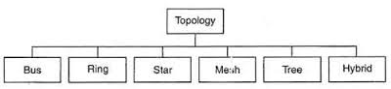
Bus topology : Bus Topology is the simplest of network topologies. In this type of topology, all the nodes (computers as well as servers) are connected to the single cable (called bus), by the help of interface connectors. This central cable is the backbone of the network and is known as Bus (thus the name). Every workstation communicates with the other device through this Bus.
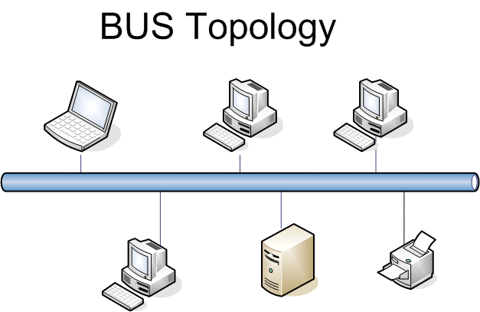

Advantages (benefits) of Bus Topology :
1) It is easy to set-up and extend bus network. 2) Cable length required for this topology is the least compared to other networks. 3) Bus topology costs very less. 4) Linear Bus network is mostly used in small networks. Good for LAN.
Disadvantages (Drawbacks) of Bus Topology are :
1) There is a limit on central cable length and number of nodes that can be connected.
2) Dependency on central cable in this topology has its disadvantages. If the main cable (i.e. bus ) encounters some problem, whole network breaks down.
3) It is difficult to detect and troubleshoot fault at individual station.
4) Maintenance costs can get higher with time.
5) Efficiency of Bus network reduces, as the number of devices connected to it increases.
Star topology :In Star topology, all the components of network are connected to the central device called “hub” which may be a hub, a router or a switch. Unlike Bus topology (discussed earlier), where nodes were connected to central cable, here all the workstations are connected to central device with a point-to-point connection. So it can be said that every computer is indirectly connected to every other node by the help of “hub".
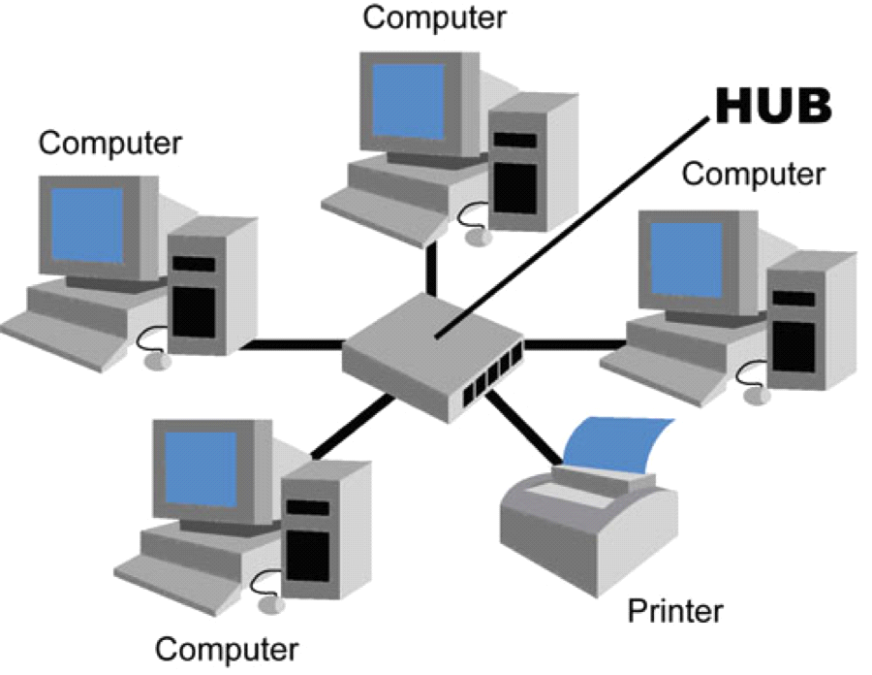

Advantages of Star Topology :
1) As compared to Bus topology it gives far much better performance, signals don’t necessarily get transmitted to all the workstations.
2) Easy to connect new nodes or devices. In star topology new nodes can be added easily without affecting rest of the network. Similarly components can also be removed easily.
3) Centralized management. It helps in monitoring the network.
4) Failure of one node or link doesn’t affect the rest of network. At the same time its easy to detect the failure and troubleshoot it.
Disadvantages of Star Topology :
1) Too much dependency on central device has its own drawbacks. If it fails whole network goes down.
2) The use of hub, a router or a switch as central device increases the overall cost of the network.
3) Performance and as well number of nodes which can be added in such topology is depended on capacity of central device.
Ring topology :In Ring Topology, all the nodes are connected to each-other in such a way that they make a closed loop. Each workstation is connected to two other components on either side, and it communicates with these two adjacent neighbors. Data travels around the network, in one direction. Sending and receiving of data takes place by the help of TOKEN.
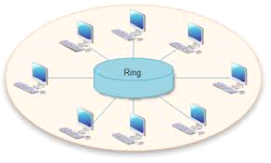
Advantages of Ring Topology :
1) This type of network topology is very organized. Each node gets to send the data when it receives an empty token. This helps to reduces chances of collision. Also in ring topology all the traffic flows in only one direction at very high speed.
2) Even when the load on the network increases, its performance is better than that of Bus topology.
3) There is no need for network server to control the connectivity between workstations.
4) Additional components do not affect the performance of network.
5) Each computer has equal access to resources.
Disadvantages of Ring Topology :
1) Each packet of data must pass through all the computers between source and destination. This makes it slower than Star topology.
2) If one workstation or port goes down, the entire network gets affected.
3) Network is highly dependent on the wire which connects different components.
Mesh Topology :In a mesh network topology, each of the network node, computer and other devices, are interconnected with one another. Every node not only sends its own signals but also relays data from other nodes. In fact a true mesh topology is the one where every node is connected to every other node in the network. This type of topology is very expensive as there are many redundant connections, thus it is not mostly used in computer networks. It is commonly used in wireless networks. Flooding or routing technique is used in mesh topology.
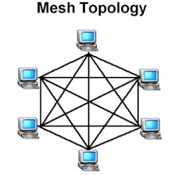
Advantages of Mesh topology :
1) Data can be transmitted from different devices simultaneously. This topology can withstand high traffic.
2) Even if one of the components fails there is always an alternative present. So data transfer doesn’t get affected.
3) Expansion and modification in topology can be done without disrupting other nodes.
Disadvantages of Mesh Topology :
1) There are high chances of redundancy in many of the network connections.
2) Overall cost of this network is way too high as compared to other network topologies.
3) Set-up and maintenance of this topology is very difficult. Even administration of the network is tough
Tree Topology : Tree Topology integrates the characteristics of Star and Bus Topology. Earlier we saw how in Physical Star network Topology, computers (nodes) are connected by each other through central hub. And we also saw in Bus Topology, work station devices are connected by the common cable called Bus. After understanding these two network configurations, we can understand tree topology better. In Tree Topology, the numbers of Star networks are connected using Bus. This main cable seems like a main stem of a tree, and other star networks as the branches. It is also called Expanded Star Topology. Ethernet protocol is commonly used in this type of topology. The diagram below will make it clear.
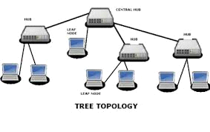
Advantages of Tree Topology :
1. It is an extension of Star and bus Topologies, so in networks where these topologies can't be implemented individually for reasons related to scalability, tree topology is the best alternative.
2. Expansion of Network is possible and easy.
3. Here, we divide the whole network into segments (star networks), which can be easily managed and maintained.
Disadvantages of Tree Topology :
1. Because of its basic structure, tree topology, relies heavily on the main bus cable, if it breaks whole network is crippled.
2. As more and more nodes and segments are added, the maintenance becomes difficult.
3. Scalability of the network depends on the type of cable used.
Hybrid Topology : Before starting about Hybrid topology, we saw that a network topology is a connection of various links and nodes, communicating with each other for transfer of data. We also saw various advantages and disadvantages of Star, Bus, Ring, Mesh and Tree topologies.
Now lets discuss what Hybrid Network topology is and why it finds its application in Wide Area Networks. Hybrid, as the name suggests, is mixture of two different things. Similarly in this type of topology we integrate two or more different topologies to form a resultant topology which has good points (as well as weaknesses) of all the constituent basic topologies rather than having characteristics of one specific topology. This combination of topologies is done according to the requirements of the organization. For example, if there exists a ring topology in one office department while a bus topology in another department, connecting these two will result in Hybrid topology. Remember connecting two similar topologies cannot be termed as Hybrid topology. Star-Ring and Star-Bus networks are most common examples of hybrid network.
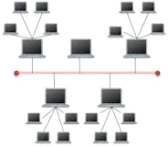
Advantages of Hybrid Network Topology :
1) Reliable: Unlike other networks, fault detection and troubleshooting is easy in this type of topology. The part in which fault is detected can be isolated from the rest of network and required corrective measures can be taken, WITHOUT affecting the functioning of rest of the network.
2) Scalable: Its easy to increase the size of network by adding new components, without disturbing existing architecture.
3) Flexible: Hybrid Network can be designed according to the requirements of the organization and by optimizing the available resources. Special care can be given to nodes where traffic is high as well as where chances of faults are high.
Disadvantages of Hybrid Topology :
1) Complexity of Design: One of the biggest drawback of hybrid topology is its design. Its not easy to design this type of architecture and its a tough job for designers. Configuration and installation process needs to be very efficient.
2) Costly Hub: The hubs used to connect two distinct networks, are very expensive. These hubs are different from usual hubs as they need to be intelligent enough to work with different architectures and should be function even if a part of network is down.
3) Costly Infrastructure: As hybrid architectures are usually larger in scale, they require a lot of cables, cooling systems, sophisticate network device etc.

